Advanced IoT & AI Development Kit
Core System and components : Raspberry Pi 5 (8GB) & ESP32-S3 Ecosystem Focus: Edge AI, Computer Vision, and Distributed IoT Protocols

1. Description & Component Overview
This laboratory kit is a high-performance development environment designed for Artificial Intelligence (AI) and Internet of Things (IoT) applications. The Raspberry Pi 5 serves as the central processing hub for Computer Vision (Open-CV), while the Fire-Beetle 2 ESP32-S3 and ESP32-S3-CAM act as edge nodes for real-time sensing and remote image capture.

Hardware Component Gallery
Component | Function
Raspberry Pi 5 (8GB) | Main computer for AI, Open-CV, and programming.
Fire-Beetle 2 ESP32-S3 | IoT hub for real-time control and WiFi/BLE.
ESP32-S3-CAM | Distributed image capture and video streaming.
27W USB-C Power Supply | Required for stable operation of Pi 5 (5.1V/5A).
32GB Micro SD Card | Stores Raspberry Pi OS and project files.
Micro HDMI to HDMI | Connects the Pi 5 to a standard monitor.
Active Cooler & Case | Protects the board and manages high thermals.
Connector Pins/Headers | For soldering/interfacing the Fire-Beetle 2.

2. Technical Pin-out & Functional Descriptions

A. Raspberry Pi 5 (40-Pin Header)
- Logic Level: 3.3V (Strict). Do not apply 5V to GPIO pins.
- Max Current: ~16mA per pin.

Pin No. | Name | Type | Description
1, 17 | 3.3V | Power | DC power output for low-power sensors.
2, 4 | 5V | Power | DC power output for fans or 5V peripherals.
3, 5 | SDA / SCL | I2C | Communication for OLEDs and digital sensors.
6, 9, 14... | GND | Ground | Common reference for the circuit.
8, 10 | TXD / RXD | UART | Serial communication/debugging interface.
12, 32, 33 | PWM | Output | Controls motor speed or LED dimming.
19, 21, 23 | MOSI/MISO/SCLK | SPI | High-speed data for displays or RFID readers.

B. Fire-Beetle 2 ESP32-S3 Pin-out
- Logic Level: 3.3V.
- Specialty: Optimized for low-power battery operation.
Label | Function | Description
VCC | Power Input | USB (5V) or Li-ion Battery (3.7V) input.
3V3 | Power Output | Regulated 3.3V output for external modules.
A0 - A4 | ADC | Analog-to-Digital: Reads variable voltage sensors.
GPIO 1-21 | Digital I/O | Standard pins for buttons, LEDs, and relays.
SDA / SCL | I2C | Connects to the Pi 5 or I2C sensors.
BOOT/RST | Control | Used for firmware flashing and system resets.

3. How to Operate (Step-by-Step)

Phase 1: Flashing the Raspberry Pi OS
- Install Tool: Download Raspberry Pi Imager on your PC.
- Select Device: Choose Raspberry Pi 5.
- Select OS: Choose Raspberry Pi OS (64-bit).
- Insert SD: Plug your 32GB SD card into the PC.
- Write: Click Next. Use "Edit Settings" to pre-configure Wi-Fi and SSH. Click Write.
- Boot: Insert the card into the Pi 5, connect the 27W Power Supply, and connect to a monitor.

Phase 2: Programming the ESP32-S3
- Environment: Open Arduino IDE.
- Board Manager: Go to File > Preferences. Add: https://raw.githubusercontent.com/espressif/arduino-esp32/gh-pages/package_esp32_index.json
- Install Core: In Tools > Board > Boards Manager, search for ESP32 and click Install.
- Select Board: Set board to DFRobot FireBeetle 2 ESP32-S3.
- Connect: Use a USB-C Data Cable. Select the correct Port.
- Upload: Write your code and click Upload. (Hold BOOT if the upload fails).

4. Do’s and Don’ts
Do | Don't
Do keep the Active Cooler running; Pi 5 throttles at 80°C. | Don't hot-swap the SD card while the Green LED is flickering.
Do use the official 27W supply to ensure 5A current delivery. | Don't connect 5V sensors to the 3.3V GPIO pins.
Do use a common GND when wiring the Pi and ESP32 together. | Don't leave the ESP32-S3-CAM in direct sunlight for long periods.

5. Safety Measures
- Thermal Safety: The Pi 5 processor is an exposed die. Avoid touching it during operation to prevent burns.
- Electrical Safety: Always disconnect the USB-C Power before changing any wiring on the GPIO headers.
- Shutdown Protocol: Always use sudo halt or the GUI shutdown to prevent SD card corruption.
- Static Protection: Touch a grounded metal object before handling the Fire-Beetle 2 to discharge static electricity.

Components Images:

1.RaspBerry pi 5
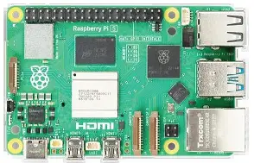

2. Fire-bettle esp 32
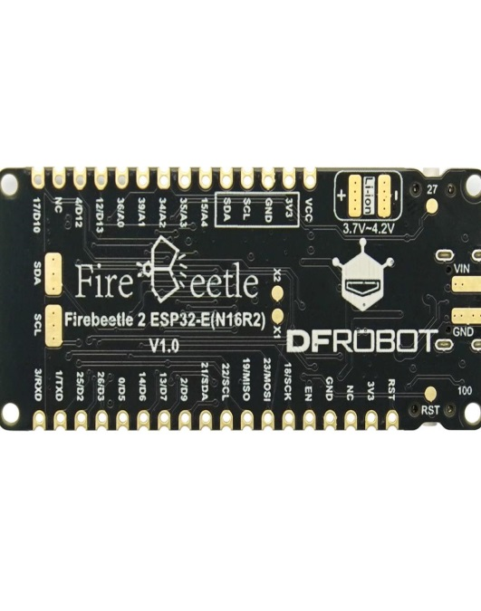
3.esp 32 cammera module
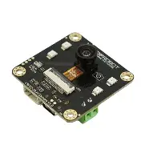

4.RaspBerry pi case
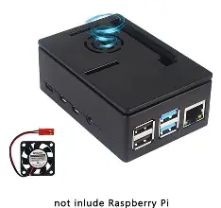
5. 27 W power Adapter for RaspBerry pi
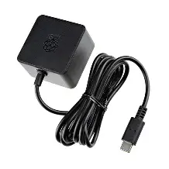
6.Micro HDMI to HDMI Cable

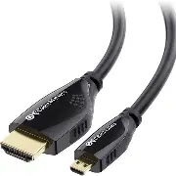

7.32 GB SD Card
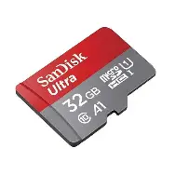
Links for raspberry pi configuration
https://youtu.be/ZH6vfvRstfM?si=Vp0DY1wYyE-MQz4J
link for firebettle esp 32
https://youtu.be/4g1uRzDVb6U?si=RbMwezJBjF2F-d3j
